Rollerball - Project 04

Team Name : stringCheese

Team Members :

Chris Schaffer, Meetkumar Savaliya, Tim Stroup, Wei Chen, Ya-Hsin Cheng (List alphabetically)

Use Cases Diagram:

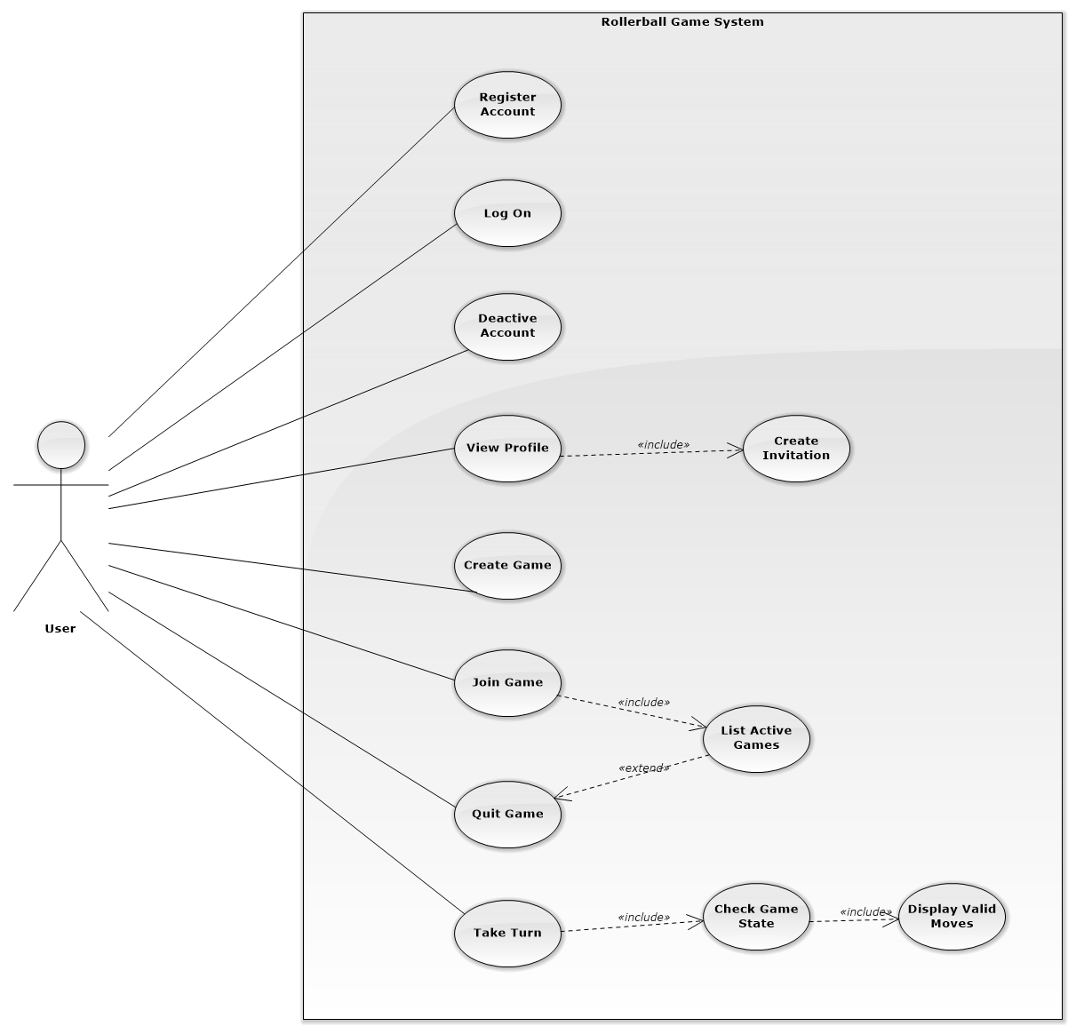

Use Case Descriptions:

|  |  |
| --- | --- |
| Use Case id: | 1 |
| Name | Register Account |
| Level | User goal |
| Primary Actor | User |
| Stakeholder  And Interest | User and System |
| Preconditions | User is connected to the system |
| Post conditions | User is registered with unique email and nickname |
| Main Success scenario | 1: User requests to register an account  2: User enters unique email address, nickname, and password  3: System Creates account  3: System reports that account was created  4: Use case ends |
| Extensions | 2A: Invalid email  1: System replies with the error in email(Already Registered, ill-formed)  2: Account is not Created  3: Return to step 1  2B: Invalid nickname  1: System replies that nickname is already registered  2: Account is not created  3: Return to step 1  2C: Network Error  1: Account is not created  2: Return to step 1 |

|  |  |
| --- | --- |
| Use Case id: | 2 |
| Name | Create Game |
| Scope | System |
| Level | User Goal |
| Primary Actor | User |
| Stakeholder  And Interest | User |
| Preconditions | User is registered and logged in to the system |
| Post conditions | Game is created |
| Main Success scenario | 1: User requests the system to create game  2: System creates game  3: System creates game id  4: System reports game creation was successful  5:Use case ends |
| Extensions | 1A: Network error  1: Game is not created  2: Use case ends |

|  |  |
| --- | --- |
| Use Case id: | 3 |
| Name | Create Invitation |
| Scope | System |
| Level | User Goal |
| Primary Actor | User |
| Stakeholder  And Interest | User |
| Preconditions | 1. User is registered and logged in 2. User has created a game |
| Post conditions | Invitations are sent |
| Main Success scenario | 1: User requests to create an invitation for a game  2: <<INCLUDE>> List Registered Users  3: User selects recipients of the invitation from the list  4: User requests to send the invitation  5: System sends invitation  6: Use case ends |
| Extensions | 1A: Invalid Game  1: System reports that you cannot create an invitation for this game  2: Use case Ends  1B: Network error  1: System reports it cannot create invitation  2: Use case ends  4A: Network error  1: System reports it cannot send an invitation  2: Use case ends |

|  |  |
| --- | --- |
| Use Case id: | 4 |
| Name | Deactivate account |
| Scope | System |
| Level | User goal |
| Primary Actor | User |
| Stakeholder  And Interest | User |
| Preconditions | User is registered and logged in |
| Post conditions | User account is deactivated |
| Main Success scenario | 1: User requests to deactivate their account  2: System request to confirm that user would like to deactivate account  3: System deactivates account and deletes user history  4: Use case ends |
| Extensions | 1A: Network error  1: Account is not deactivated  2: System reports account was not deactivated  3: Use case ends  2A: cancel deactivation  1: User responds no  2: User account is not deactivated  3: Use case ends |

|  |  |
| --- | --- |
| Use Case id: | 5 |
| Name | Join Game |
| Scope | System |
| Level | User Goal |
| Primary Actor | User |
| Stakeholder  And Interest | User |
| Preconditions | 1. User is registered and logged in.  2. User has received an invitation for a game with Game ID |
| Post conditions | User joins Game |
| Main Success scenario | 1: User requests join match screen  2: User enters game ID  3: User enters the game  4: Use case ends |
| Extensions | 2A: Game is full  1: System responds that game is full  2: User does not join game  3: Use case ends  2B: Game is no longer active  1: System responds that game is no longer active  2: User does not join game  3: Use case ends  2C: Network error  1: User is not entered into game  2: System reports it cannot connect to the game  3: Use case ends |

|  |  |
| --- | --- |
| Use Case id: | 6 |
| Name | View Profile |
| Scope | System |
| Level | User Goal |
| Primary Actor | User |
| Stakeholder  And Interest | User |
| Preconditions | 1. User is registered and logged in. |
| Post conditions | User profile is shown |
| Main Success scenario | 1: <<INCLUDE>> List Registered Users  2: User selects user from list  2: User requests to view profile  3: System displays profile information  4: Use case ends |
| Extensions | 2A: Network error  1: System does not display profile information  2: System reports it cannot display profile  3: Use case ends |

|  |  |
| --- | --- |
| Use Case id: | 7 |
| Name | Log on |
| Scope | System |
| Level | subfunction |
| Primary Actor | User |
| Stakeholder  And Interest | User |
| Preconditions | User is Registered. |
| Post conditions | User is logged in |
| Main Success scenario | 1: User enters nickname and password  2: User requests to log on to the system  3: User is logged in  4: Use case ends |
| Extensions | 2A: invalid password or nickname  1:User is not logged in  2: System reports password or nickname does not match a valid pair  3: Use case ends  2B: Network error  1: User is not logged in  2: System reports it cannot connect  3: Use case ends |

|  |  |
| --- | --- |
| Use Case id: | 8 |
| Name | Quit game |
| Scope | System |
| Level | User Goal |
| Primary Actor | User |
| Stakeholder  And Interest | User |
| Preconditions | 1. User is registered and logged in.  2. User has created or joined a game. |
| Post conditions | User has quit the game |
| Main Success scenario | 1: <<INCLUDE>> List active games  2: User selects and active game from the list  3: User requests to quit the game.  4: User quits the game  5: <<INCLUDE>>Save completed game  6: System reports game was successfully quit  7: Use case ends |
| Extensions | 3A: Network error  1: User does not quit game  2: System reports it cannot connect and game was not quit  3: Use case ends |

|  |  |
| --- | --- |
| Use Case id: | 9 |
| Name | List active games |
| Scope | System |
| Level | User Goal |
| Primary Actor | User |
| Stakeholder  And Interest | User |
| Preconditions | User is registered and logged in. |
| Post conditions | User’s Active Games are listed |
| Main Success scenario | 1: User requests to list their active games  2: Active games are listed  3: Use case ends |
| Extensions | 1A: Network error  1: Active games are not lister  2: System reports it cannot connect  3: Use case ends  2a: No active games  1: System responds that there are no active games  2: Use case ends |

|  |  |
| --- | --- |
| Use Case id: | 10 |
| Name | Take Turn |
| Scope | System |
| Level | User goal |
| Primary Actor | User |
| Stakeholder  And Interest | User |
| Preconditions | 1. User is logged in and registered  2. It is the User’s turn |
| Post conditions | User has moved a piece and turn is over |
| Main Success scenario | 1: <<INCLUDE>> List Active Games  2: User selects a game  3: User selects piece to move  4: <<INCLUDE>> Get valid moves  5: User selects move from valid moves  6: piece is moved  7: <<INCLUDE>> Update game state  8: Use case ends |
| Extensions | 3A: Invalid piece  1: System reports user can not move this piece  2: return to main flow step 3  4A: No valid moves  1: The System reports no valid moves  2: return to main flow step 3  5A: Game is invalid  1: System reports that game is no longer valid  2: Use case ends  7A: Game is over  1: <<INCLUDE>> Save completed game  2: System reports game is completed  3: Use case ends |

|  |  |
| --- | --- |
| Use Case id: | 11 |
| Name | Update Game State |
| Scope | System |
| Level | subfunction |
| Primary Actor | System |
| Stakeholder  And Interest | System |
| Preconditions | 1. User is logged in and registered  2. User has moved a piece |
| Post conditions | Game state has been updated |
| Main Success scenario | 1: System saves the new state  2: The system checks whether the game is over  3: Use case ends |
| Extensions | 2A: The game is over  1: <<INCLUDE>> Save completed game  2: The system reports that the game is over  3: Use case ends |

|  |  |
| --- | --- |
| Use Case id: | 12 |
| Name | Display Valid Moves |
| Scope | System |
| Level | subfunction |
| Primary Actor | System |
| Stakeholder  And Interest | System |
| Preconditions | 1. User is logged in and registered  2. User taking a turn  3. User has selected a valid piece |
| Post conditions | Valid moves are returned |
| Main Success scenario | 1: The system checks for valid moves for a piece and board state  2: The system returns the valid moves for a piece and board state  3: Use case ends |
| Extensions | 1A: No valid moves  1: The system reports there are no valid moves  2: Use case ends |

|  |  |
| --- | --- |
| Use Case id: | 13 |
| Name | Save Completed game |
| Scope | System |
| Level | subfunction |
| Primary Actor | System |
| Stakeholder  And Interest | System |
| Preconditions | 1. User is logged in and registered  2. The game is over |
| Post conditions | Finished game is saved in player history |
| Main Success scenario | 1: The system saves the finished game in each players’ history  2: The system records the winner of the game  3: Use case ends |
| Extensions | 2A: The game was a tie  1: The system records the game as a tie  2: Use case ends |

Domain Model :

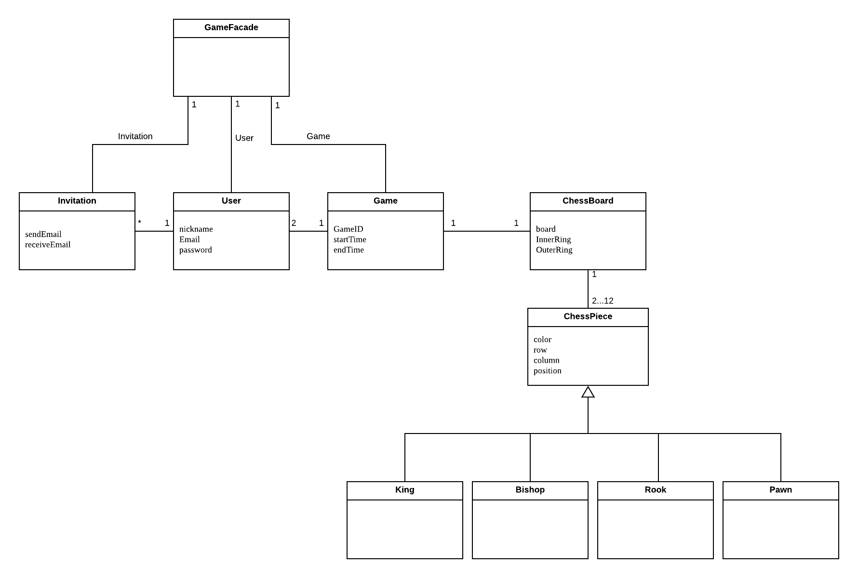

Glossary :

|  |  |
| --- | --- |
| ChessBoard | The board is the combination of spaces that a piece may move and the boundaries of the game. |
| ChessPiece | The game is played with different pieces; each with unique movements and rules. Each player has either six white or six black pieces that include two pawns, one king, one bishop and two rooks. |
| Game | A game consists of two users who take turns moving their pieces around the board. |
| GameFacade |  |
| Invitation | A user may send an invitation to another user as well as receive an invitation from another user to play a game. A user may send multiple invitations to multiple users to play a game. |
| User | A person registered to play the game. They may send invitations to other users to play one or more games at a time. Each user has a user profile. |

Design documents:

Class diagram – Game

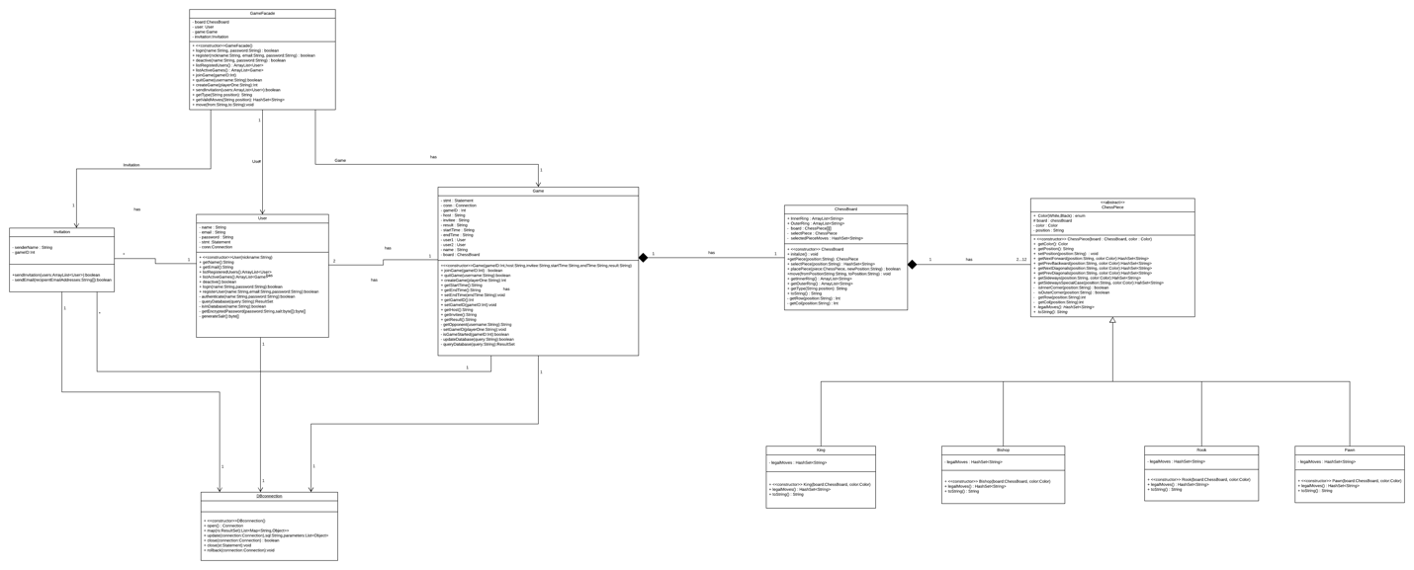

Class diagram – UI Interface

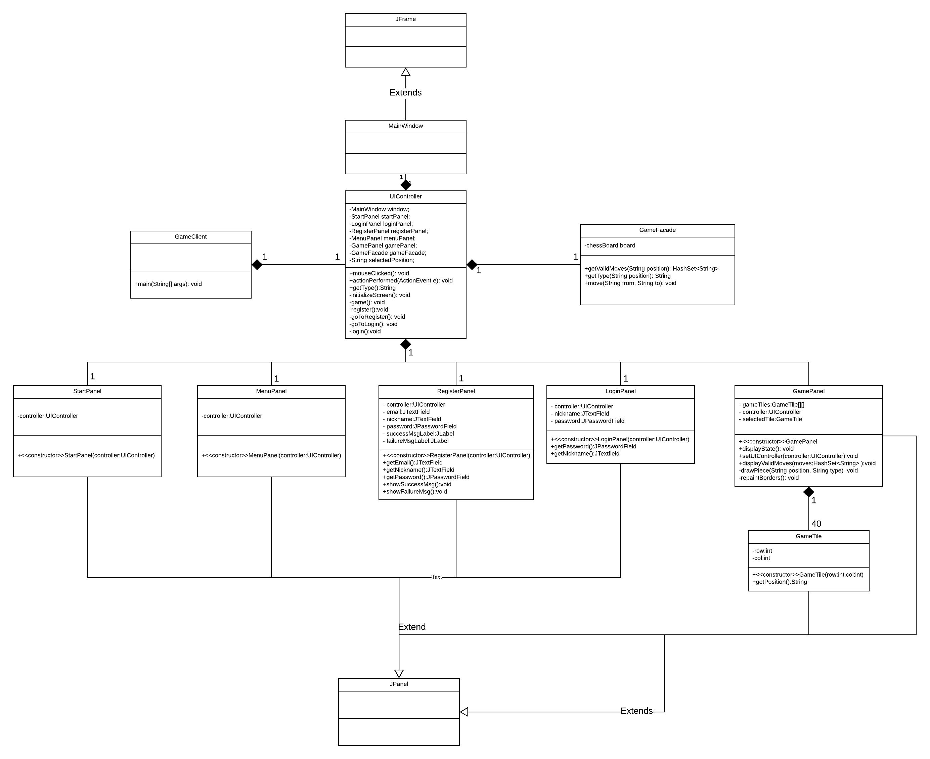

Package diagram

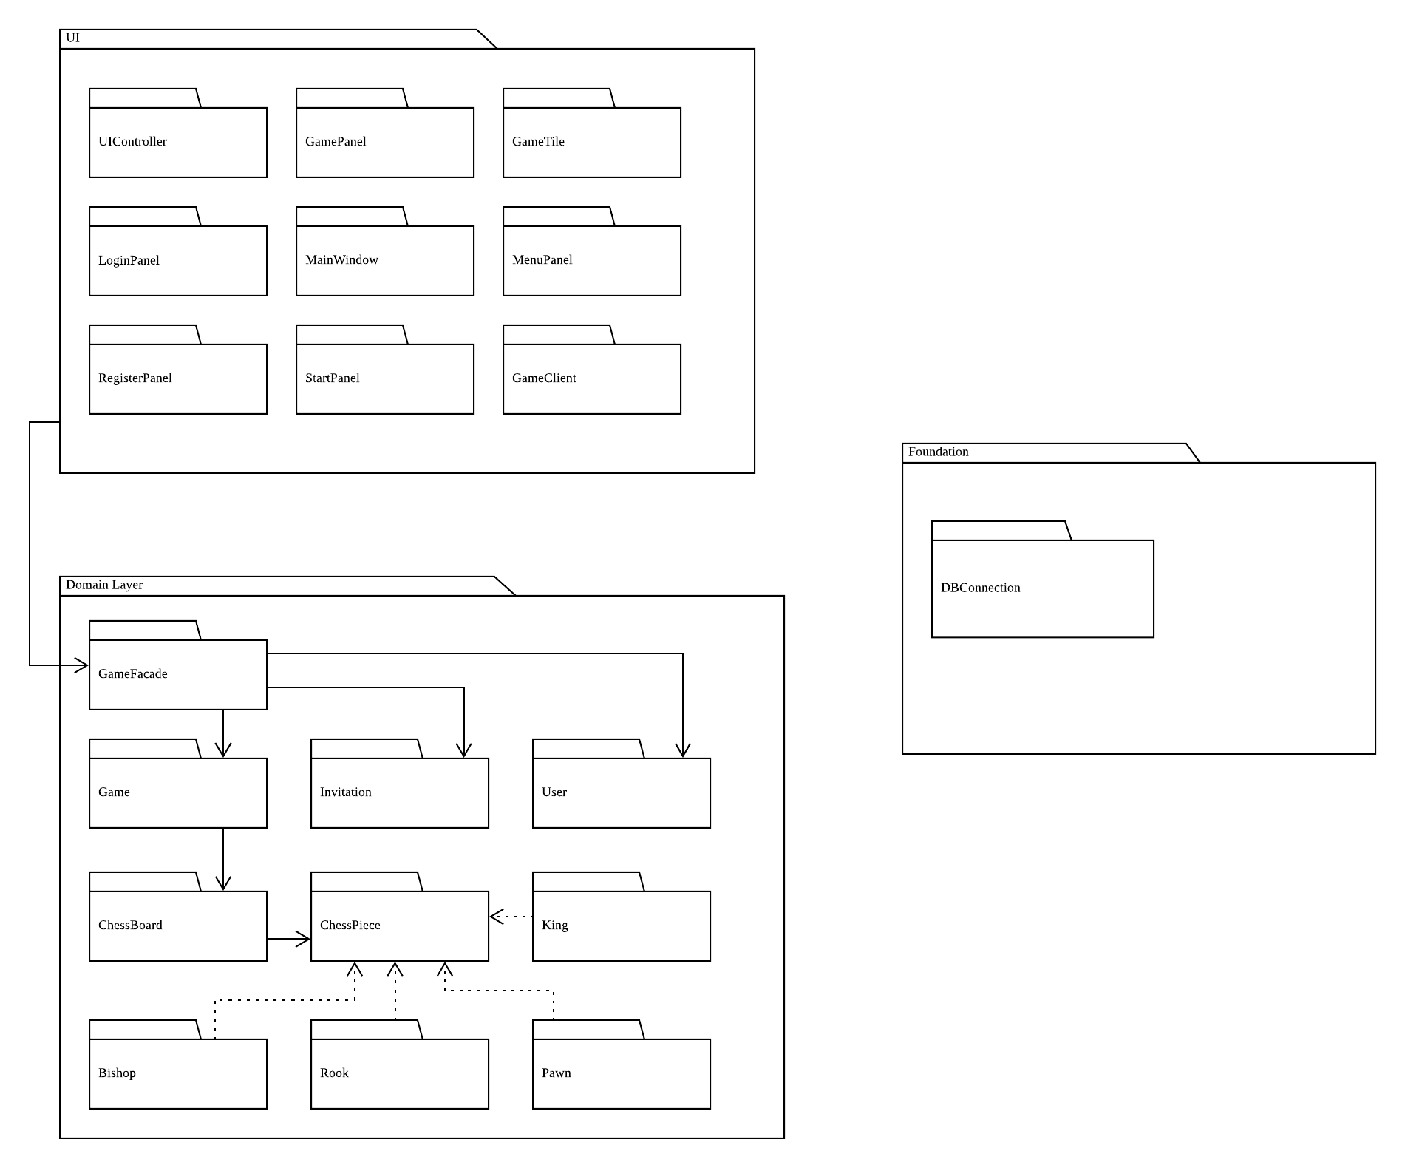

Sequence Diagrams :

評語

• Sequence diagrams

○ The diagrams don't reflect the system implementation.

結束

* three key/difficult/interesting sequence diagrams.

* Take Turn
* Join Games
* Send Invitation

Source code

. The code should include the JUnit test cases. Well-documented code will be rewarded.

Testing document

The document should contain , i.e., system test from the user’s

point of view.

評語：[Testing document]

• The document should include details of system tests and any kind of testing performed manually

結束

Development manual

The document should describe how to set up the development environment

to work on the project, how to run the system as a developer, and how to run the tests (put yourself

in the place of a newcomer—what are the necessary steps for her to start working on the project?).

評語：[Development manual]

• Instructions to run the tests are missing

• As a general recommendation, the manual should include the steps to import the code into the preferred IDE.

結束

Refactoring and design pattern list

* Structural pattern - Façade

This is a log of the refactoring operations that you have performed and the design patterns in your application. This task can be facilitated by including the applied refactoring operations and purpose (e.g., move method doA to class myA to comply with the information expert pattern) in the commit messages of your repository. )

Traceability link matrix

|  |  |  |  |  |  |  |
| --- | --- | --- | --- | --- | --- | --- |
|  | ChessBoard | ChessPiece | Game | Invitation | User | DBconnection |
| UC1-Register Account |  |  |  |  | X | X |
| UC2-Create Game |  |  | X |  |  | X |
| UC3-Create Invitation |  |  |  | X |  | X |
| UC4-Deactivate account |  |  |  |  | X | X |
| UC5-Join Game |  |  | X |  |  | X |
| UC6-View Profile |  |  |  |  | X | X |
| UC7-Log on |  |  |  |  | X | X |
| UC8-Quit game |  |  | X |  |  | X |
| UC9-List active games |  |  | X |  |  | X |
| UC10-Take Turn | X | X | X |  | X | X |
| UC11-Update Game State | X |  | X |  |  | X |
| UC12-Display Valid Moves | X | X | X |  | X |  |

This is a spreadsheet document showing the traceability links between the

use cases and the code. While each row represents a use case, each column represents an implemented class in the system. A mark in the cell intersecting the use case *UC-1* and the class *MyClassB* indicates that the class *MyClassB* is directly involved in the implementation of the use case *UC-1*, as shown next:

評語：[Traceability link matrix]

• The TLM doesn't match the current implementation of the system--many classes are missing from the TLM

結束

Challenges and lessons learned

This is a document describing the challenges you faced during the development of the project and the lessons you learned about team work and software design and development.

**Presentation**. The final delivery of the project is to be presented during class. Different from the previous presentations, this one should show the whole project development experience and include all the artifacts generated during this process. A demo, of course, is expected.

* 1. package diagram( showing the logical architecture of the *X game*. )
  2. class diagram不同